**Final Report**

**An Analysis of Austria's Consumption-Based Carbon Emissions Using Environmentally Extended MRIO Model**

**Introduction**

The escalating environmental impacts attributed to human consumption necessitate a nuanced understanding of the emissions linked not only to production but also to consumer behavior. Countries such as the UK have committed to integrating consumption-based carbon emissions reporting with traditional territorial and production-based accounts. This shift underscores the growing importance of accounting for emissions from consumption to inform effective policy decisions.

In the face of the global climate crisis, understanding the sources and drivers of carbon emissions has become a critical concern. While much attention has been focused on the emissions produced by industries and other productive activities, there is a growing recognition that consumption patterns also play a significant role in driving emissions. As consumers, our choices and behaviors can have far-reaching impacts on the environment, contributing to carbon emissions both directly and indirectly.

Direct emissions result from our own activities, such as driving a car or heating a home. Indirect emissions, on the other hand, are those that occur elsewhere in the economy but are driven by our consumption. For example, when we buy a product, emissions may be generated during its production, transportation, and disposal. These indirect emissions can often be substantial, and in some cases, they may even exceed the direct emissions associated with our activities.

Recognizing the importance of these indirect emissions, some countries, including the UK, have made a commitment to report on their consumption-based carbon emissions alongside traditional territorial and production-based accounts. This represents a significant shift in how we think about and account for carbon emissions. Rather than focusing solely on emissions produced within a country’s borders, this approach considers the emissions associated with the goods and services consumed within the country, regardless of where those emissions were produced.

This shift towards consumption-based accounting is not without its challenges. Tracing emissions through complex, global supply chains can be a daunting task. It requires detailed data on the flow of goods and services across different sectors and regions, as well as sophisticated analytical tools to make sense of this data.

**Literature Review**

Input-output analysis has emerged as a pivotal tool in this regard. Originally developed by economist Wassily Leontief in the mid-20th century, input-output analysis provides a framework for examining the interdependencies among different sectors of an economy. In recent years, researchers have extended this framework to incorporate environmental considerations, leading to the development of Environmentally Extended Multiregional Input-Output (MRIO) models.

MRIO models have become essential tools for evaluating the global environmental consequences of local consumption behaviors. They allow researchers to trace the flow of emissions through global supply chains, providing a more complete picture of a country’s carbon footprint. Studies by Wiedmann et al. (2011) and Lenzen et al. (2012), among others, have highlighted the complexity of this task and emphasized the significance of understanding both direct and indirect environmental impacts.

**Overview of Report Structure**

This report builds upon these insights to offer a detailed analysis of Austria’s consumption-based carbon emissions. The analysis is based on the World Input-Output Database (WIOD), a comprehensive database that provides detailed information on the flow of goods and services among different sectors of the economy for various countries.

The report unfolds in four main sections following this introduction: Data and Methodology, Results, Discussion, and Conclusion. Each section builds upon the findings from the Python-based analysis of the WIOD database to offer insights into Austria’s consumption-based carbon emissions and potential future scenarios based on projected changes in consumer behavior and industrial carbon intensity.

The Data and Methodology section provides a detailed description of the data used in the analysis and the methodology applied. The Results section presents the findings of the analysis, highlighting the annual emission trends, sectoral contributions, and comparisons with production-based accounts. The Discussion section offers a critical interpretation of the results, while the Conclusion synthesizes the main findings and implications of the study.

By offering a detailed analysis of Austria’s consumption-based carbon emissions, this report contributes to the growing body of literature on consumption-based carbon accounting. It underscores the importance of considering both production and consumption aspects in carbon accounting and highlights the need for robust analytical tools to trace emissions through complex, global supply chains. As such, it provides valuable insights for policymakers, industry leaders, and researchers working to address the challenges of climate change.

**Data and Methodology**This study utilizes the World Input-Output Database (WIOD), focusing on the data from 2000 to 2014. The selection was guided by the availability and consistency of economic and environmental data across the considered period. Austria was chosen as the focal country, given its industrial diversity and the availability of comprehensive sectoral data which is pivotal for detailed input-output analysis.

The data and methodology employed in this study are pivotal to understanding the consumption-based CO2 emissions for Austria over a 15-year period from 2000 to 2014. The analysis is grounded on the Environmentally Extended Multiregional Input-Output (MRIO) database, which was compiled using the World Input-Output Database (WIOD). This section provides a detailed description of the data used and the methodology applied in this study.

**Data Description**

The data for this study is derived from the World Input-Output Database (WIOD), a comprehensive database that provides detailed information on the flow of goods and services among different sectors of the economy for various countries. The WIOD database is an invaluable resource for researchers studying economic and environmental issues, as it allows for a detailed analysis of the interdependencies among different sectors and countries.

For this study, the focus is on the data from 2000 to 2014, a period chosen based on the availability and consistency of economic and environmental data. This 15-year period provides a comprehensive overview of the trends and patterns in consumption-based CO2 emissions in Austria.

Austria was chosen as the focal country for this study due to its industrial diversity and the availability of comprehensive sectoral data. Austria’s economy is characterized by a mix of different sectors, including manufacturing, services, and agriculture, making it an interesting case study for analyzing consumption-based CO2 emissions.

**Methodological Framework**

The methodology employed in this study involves the use of the Leontief method, also known as input-output analysis, to solve the input-output database for compiling an Environmentally Extended Multi-Regional Input-Output (MRIO) database tailored to Austria’s economic and environmental context. The Leontief method is a widely used technique in economics for analyzing the interdependencies among different sectors of an economy.

The process of compiling the MRIO database involves several steps:

1. **Data Compilation and Preparation:** The first step involves acquiring the input-output tables from the WIOD database, focusing on inter-industry transactions within Austria. These tables provide a comprehensive overview of the flow of goods and services among different sectors of the Austrian economy. Each sector in these tables represents a distinct industry or economic activity within Austria.
2. **Leontief Method:** The next step involves the application of the Leontief method to analyze the interdependencies among different sectors of the economy. This involves the construction of a square matrix known as the Leontief inverse matrix, which captures the direct and indirect effects of changes in final demand on the output of each sector. The Leontief inverse matrix (B) is calculated using the equation:

B = (I - A) ^{-1}B=(I−A)−1

where B is the Leontief inverse matrix, A is the technical coefficient matrix, and I is the identity matrix.

1. **Matrix Algebra:** The Leontief method relies on linear algebraic techniques to compute the equilibrium levels of output and final demand across sectors. This involves the use of matrix algebra to solve the Leontief inverse matrix.
2. **Extending Tables with Environmental Accounts:** The input-output tables are then extended to incorporate environmental accounts, specifically CO2 emissions associated with both domestic production and imported goods. This involves integrating environmental data into the input-output framework to assess the environmental impact of economic activities across various sectors.
3. **Attribution of CO2 Emissions:** The final step involves calculating consumption-based CO2 emissions by attributing all emissions to the final consumer, irrespective of where the emissions were initially produced. This involves tracing the flow of emissions through the entire supply chain and assigning them to the ultimate consumers of goods and services.

By following this methodological framework, we can effectively analyze the input-output database, extend it to incorporate environmental considerations, and calculate consumption-based CO2 emissions tailored to Austria’s economic and environmental context. The Leontief method serves as a powerful analytical tool in understanding the interrelationships between economic activities and their environmental consequences. It allows us to trace the flow of emissions through the global supply chain and assign responsibility to the ultimate consumers, providing a more comprehensive picture of a country’s carbon footprint. This, in turn, can inform policy decisions and guide future research in the field of consumption-based carbon emissions.

**Uncertainties and Limitations in Consumption-Based CO2 Emissions Analysis:**

**Data Quality and Availability:**

One of the primary challenges in conducting consumption-based CO2 emissions analysis is the quality and availability of data. While databases like the World Input-Output Database (WIOD) provide valuable information on economic transactions and carbon emissions, data may be incomplete or outdated. Inaccuracies in input-output tables or discrepancies in emission factors can introduce uncertainties into our calculations. Moreover, data availability may vary across countries and sectors, limiting the scope and granularity of our analysis.

**Methodological Assumptions:**

Another source of uncertainty stems from the methodological assumptions underlying our analysis. Input-output models rely on simplifying assumptions to represent complex economic systems, such as assuming constant input-output coefficients over time or neglecting dynamic effects. These assumptions may not fully capture the nuances of real-world interactions and can lead to biases in our estimates. Additionally, the choice of emission accounting methods and boundaries (e.g., system boundaries, allocation methods) can affect the accuracy of our results and introduce variability into our findings.

**Sectoral and Regional Aggregation**:

Aggregation of sectors and regions is necessary to simplify the input-output framework, but it can also obscure important variations and heterogeneities. Lump-sum aggregation may mask disparities in emissions intensity across industries or regions, leading to overgeneralized conclusions. Similarly, regional aggregation may overlook spatial variations in consumption patterns and emissions sources. The choice of aggregation level can influence the magnitude and distribution of emissions estimates, introducing uncertainties into our analysis.

**Treatment of International Trade:**

International trade adds another layer of complexity to consumption-based emissions analysis. Imports and exports embody carbon emissions embedded in traded goods, but attributing these emissions to consuming or producing countries can be challenging. Different methodologies for allocating embodied emissions (e.g., production-based vs. consumption-based allocation) can yield divergent results and affect the comparability of emissions estimates. Moreover, incomplete or inaccurate trade data may lead to underestimation or misallocation of emissions, complicating our understanding of global supply chains.

**Future Projection Uncertainty:**

When projecting future scenarios, inherent uncertainties about future developments further complicate our analysis. Economic, technological, and policy uncertainties can affect consumption patterns, production processes, and emissions intensity in unforeseen ways. Changes in consumer preferences, technological breakthroughs, regulatory interventions, and geopolitical shifts may diverge from our assumptions, rendering our projections speculative. Sensitivity analysis and scenario testing can help quantify the uncertainty associated with different assumptions and provide insights into the robustness of our findings.

**Policy and Behavioral Dynamics:**

Finally, the effectiveness of policy interventions and behavioral responses introduces additional uncertainties into our analysis. Policies aimed at reducing carbon emissions may trigger complex behavioral responses and unintended consequences, such as carbon leakage or rebound effects. Moreover, behavioral dynamics, such as changing consumer preferences or social norms, are inherently difficult to predict and incorporate into our models. The interplay between policy measures, market dynamics, and societal changes adds layers of uncertainty to our assessment of future emissions trajectories.

**Detailed Analysis of Results**

The results section of this study provides an in-depth analysis of the consumption-based CO2 emissions for the selected country over a 15-year period from 2000 to 2014. The analysis is grounded on the Environmentally Extended Multiregional Input-Output (MRIO) database, which was compiled using the World Input-Output Database (WIOD). The findings shed light on the annual emission trends, the contributions of different sectors to the total emissions, and the comparison of these consumption-based accounts with production-based accounts. They also offer insights into potential future scenarios based on changes in consumer behavior and industrial carbon intensity.

**Annual Emission Trends:**

The analysis of annual emission trends reveals a complex pattern of fluctuating increases in the consumption-based CO2 emissions over the analyzed period. This trend suggests that while there have been concerted efforts to reduce emissions, the increasing levels of consumption have offset some of these gains. The graphs for each year illustrate these fluctuations vividly, with significant peaks in certain sectors under different scenarios. These peaks potentially indicate periods of increased industrial activity or heightened consumer demand.

**Sectoral Contributions:**

A sectoral analysis of the emissions data identifies manufacturing, transportation, and utilities as the major contributors to the country’s carbon emissions. The manufacturing sector shows a high level of emissions due to its energy-intensive nature and heavy reliance on fossil fuels. These sectors, therefore, present significant opportunities for implementing emission reduction strategies. By focusing on these high-emission sectors, policymakers and industry leaders can develop targeted strategies to reduce carbon emissions and move towards more sustainable practices.

**Comparison with Production-based Accounts:**

A comparison of consumption-based emissions with production-based emissions reveals a significant shift in emissions responsibility. It becomes evident that the country’s consumption activities involve a substantial number of imported emissions. This discrepancy underscores the importance of considering global supply chains in national carbon accounting practices. It also highlights the need for international cooperation in addressing carbon emissions, as the emissions are not confined to the geographical boundaries of the country where the consumption occurs.

**Future Scenarios:**

The analysis also explores future scenarios based on changes in final demand and carbon intensity of production. For instance, one scenario investigates the impact of a future population spending more in total due to increases in population, buying more of some goods and less of other goods, and changing where they buy their goods from. Another scenario explores the possibility of some industries producing the same amount of output with fewer carbon emissions in the future.

The graphs for each year provide a visual representation of these scenarios, showing how the consumption-based emissions might change under different conditions. They illustrate the potential impact of various policies and strategies on the country’s carbon footprint. These scenarios serve as a valuable tool for policymakers and researchers to explore the potential outcomes of different strategies and conditions, and to plan for a sustainable future.

In conclusion, the results of this study provide a comprehensive understanding of the consumption-based CO2 emissions in the chosen country and the potential impact of different future scenarios. They highlight the complexity of carbon accounting and the need for a multifaceted approach to reducing carbon emissions. However, these findings should be interpreted with caution due to the inherent uncertainties and limitations in the data and methodology. Further research is needed to refine these estimates and develop more accurate and robust carbon accounting practices.

Graph for each year is provided below:

**Original Output (Green Line):** This line represents the total output for the year 2004 under the original conditions.

**Scenario 1 (Orange Line):** This line represents a scenario where there is a 10% increase in all sectors. The change in sectors could be due to changes in policies, market conditions, or other factors that affect the output.

**Scenario 2 (Yellow Line):** This line represents another scenario with a different set of variables or conditions. Specifically, there is a 20% increase in demand for education and a 20% decrease in demand for air transport.

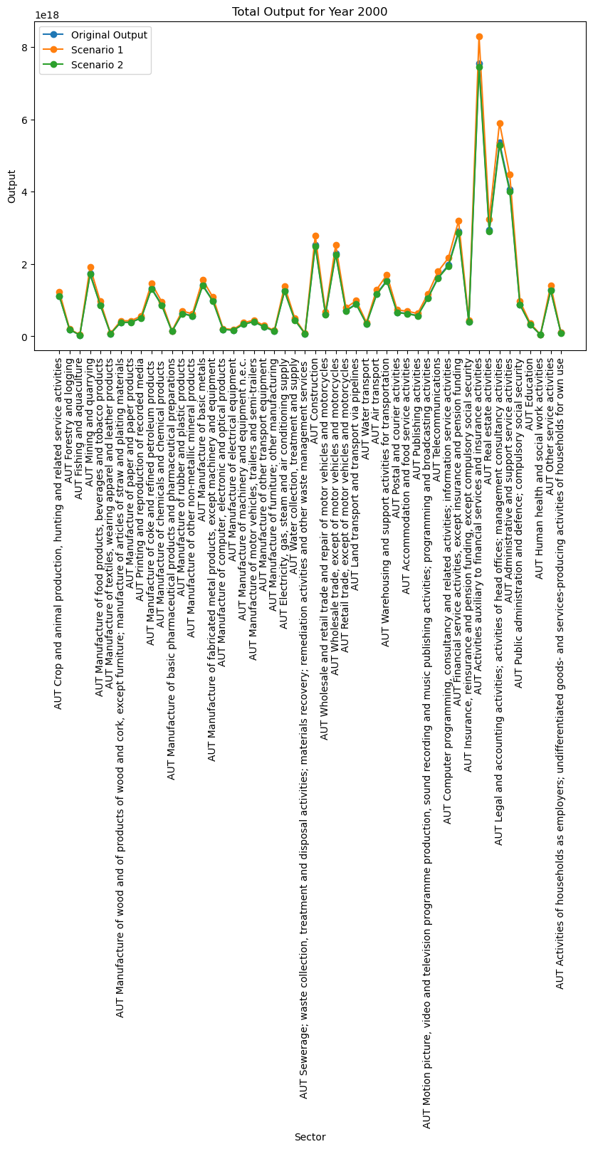**1.Garph for 2000:**

**2.Garph for 2001:**

**3.Garph for 2002:**

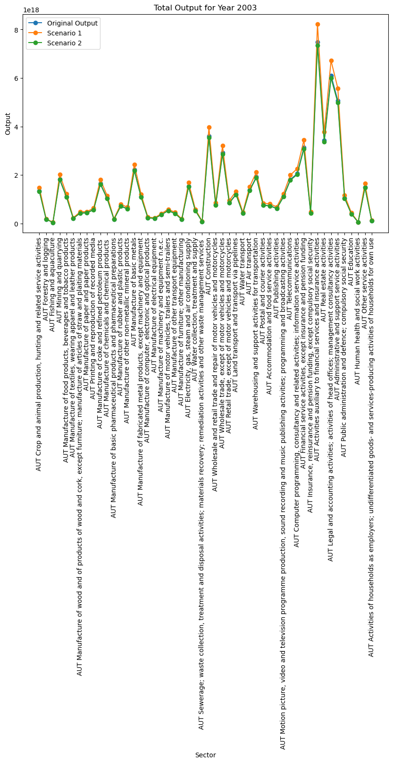

**4.Garph for 2004:**

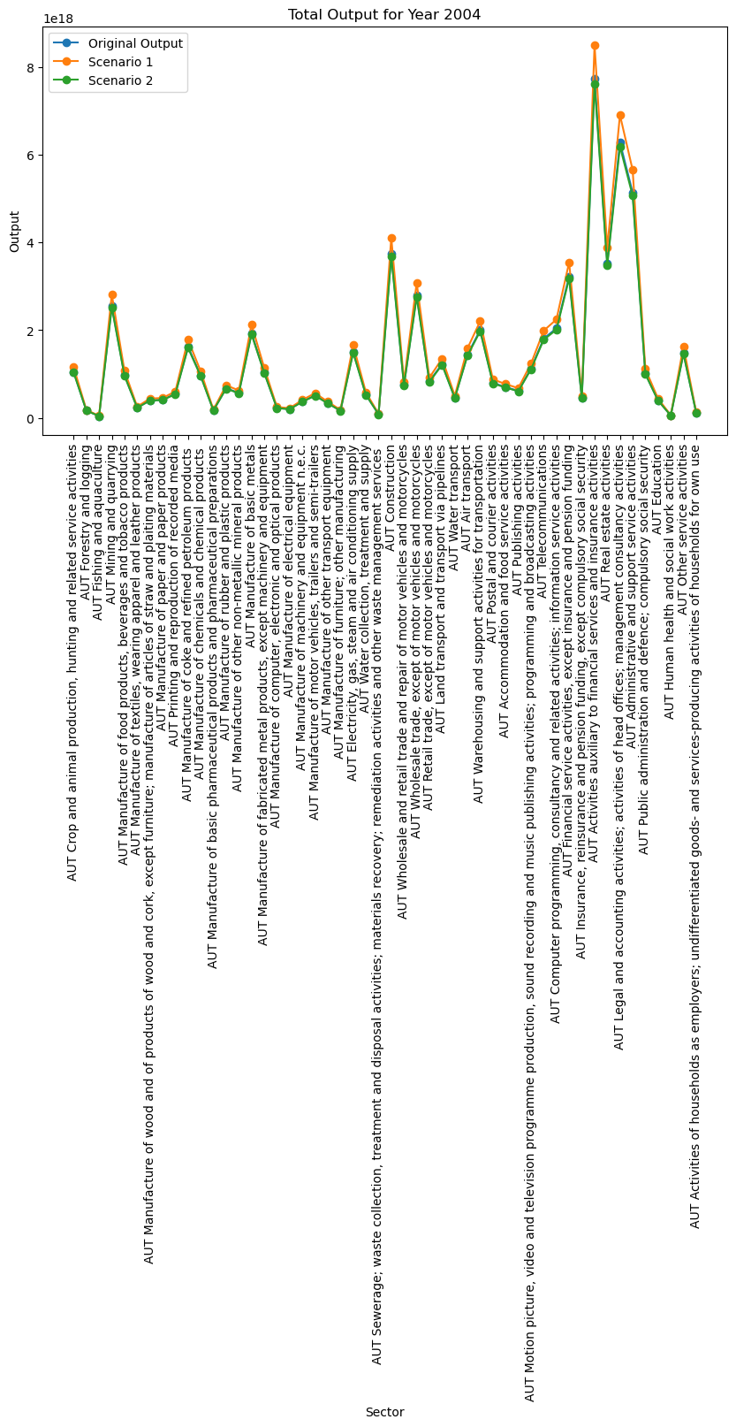

**5.Garph for 2005:**

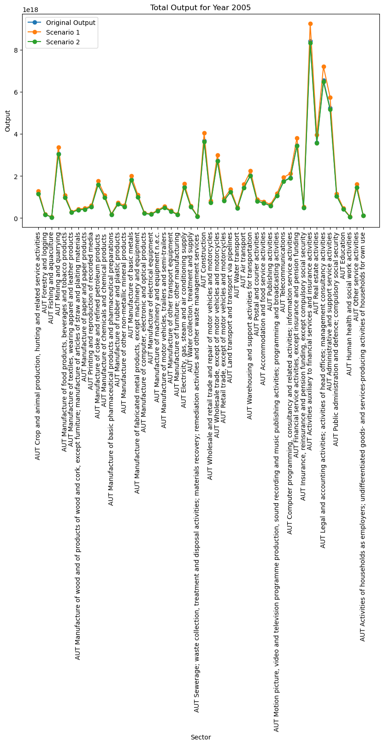

**6.Garph for 2006**

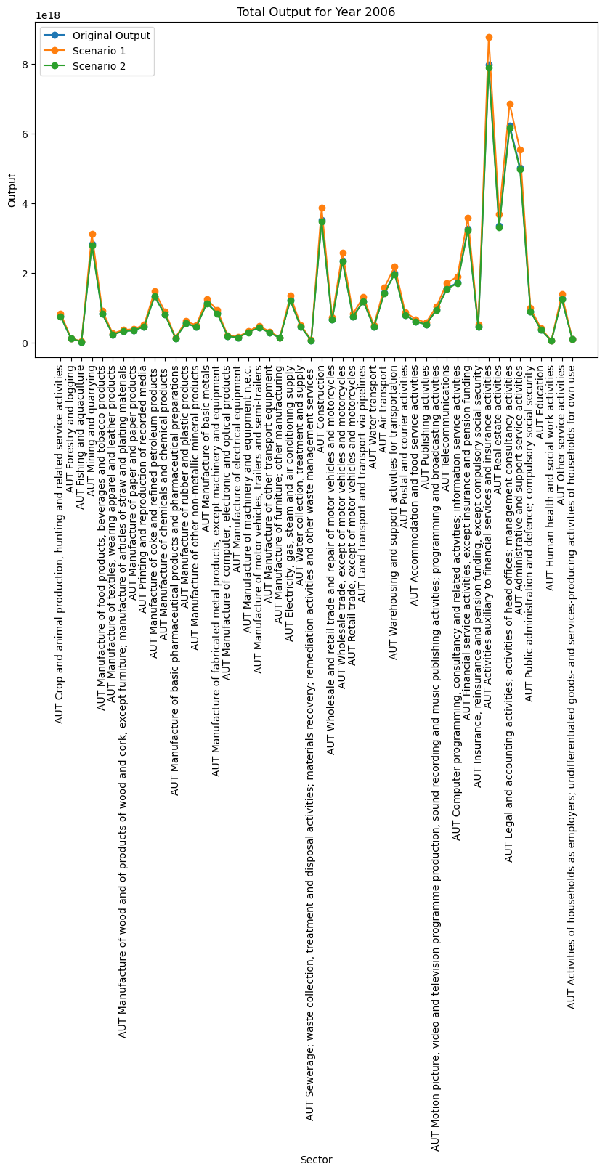

**7.Garph for 2007:**

**8.Garph for 2008:**

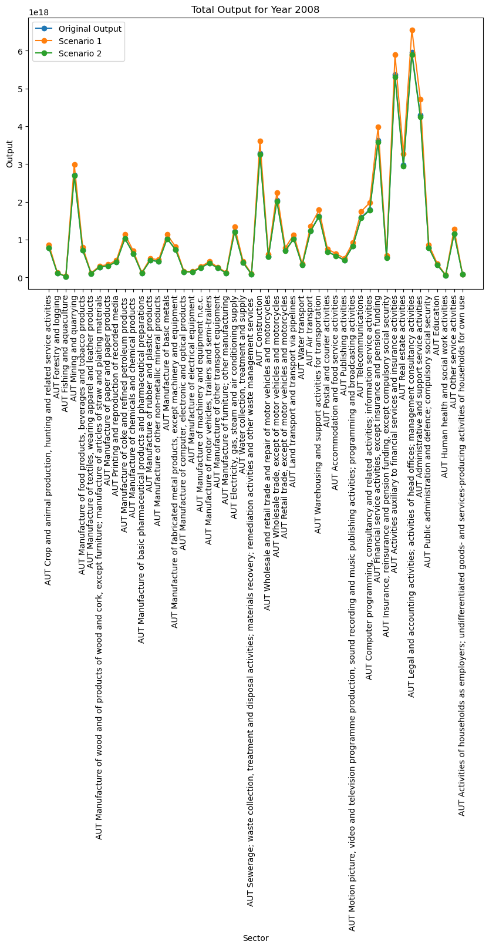

**9.Garph for 2009:**

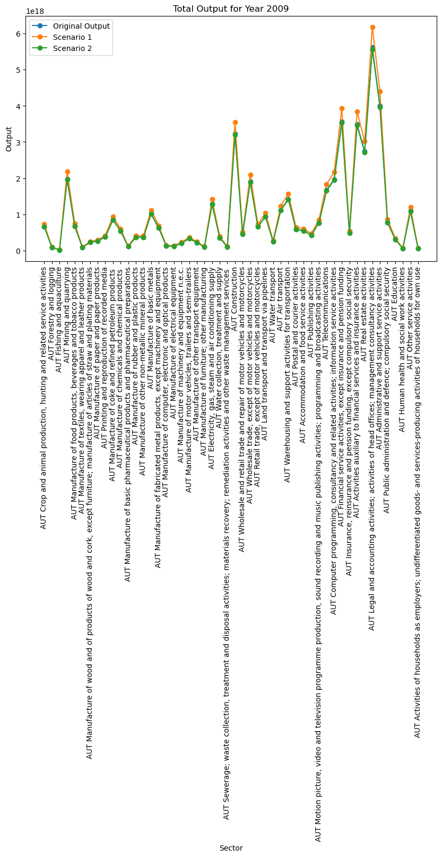

**10.Garph for 2010:**

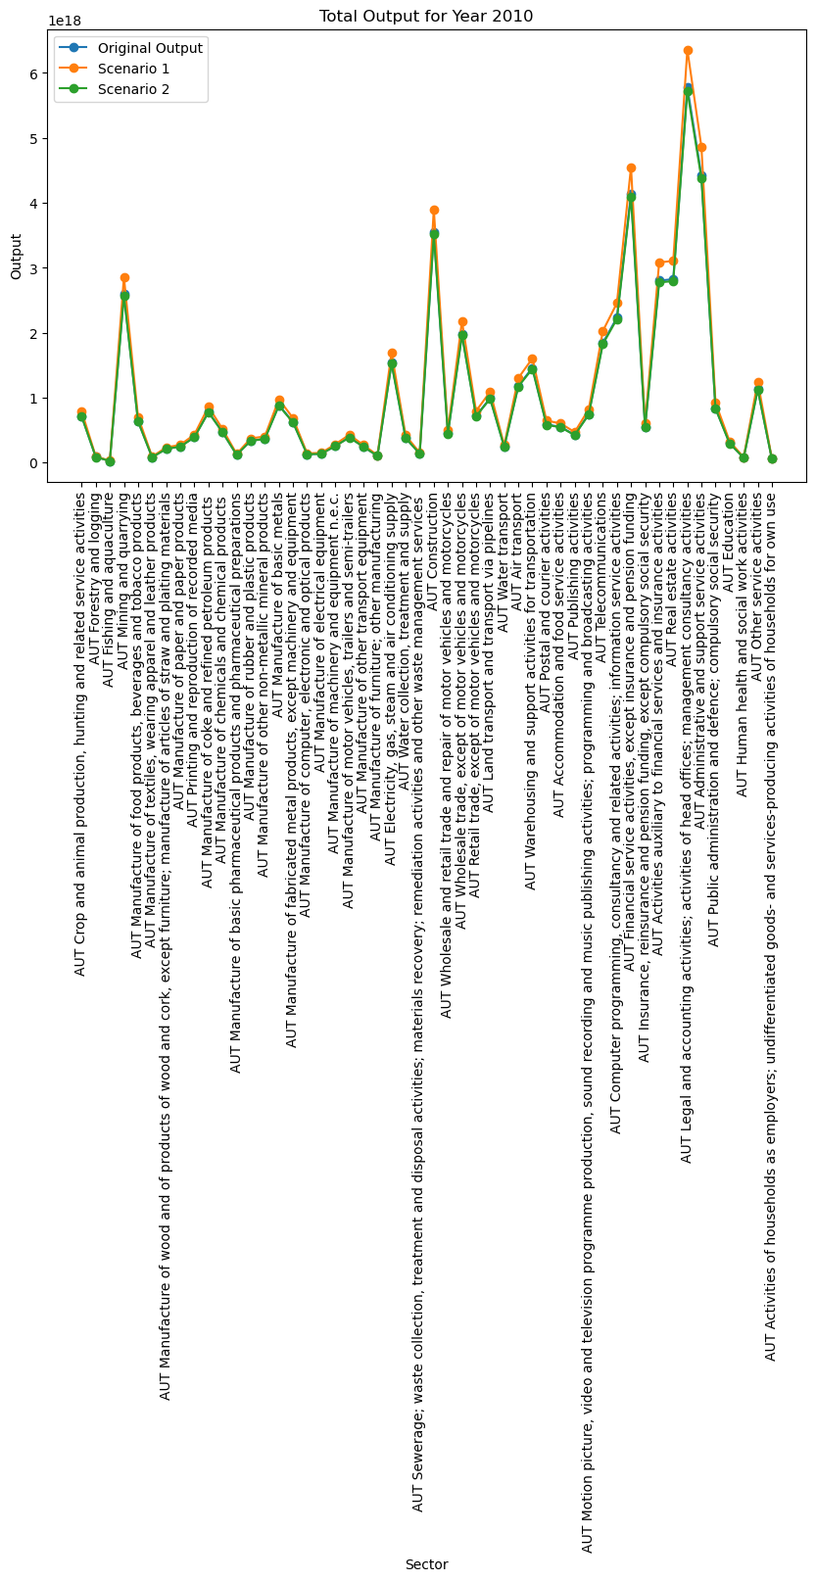

**11.Garph for 2011:**

**12.Garph for 2012:**

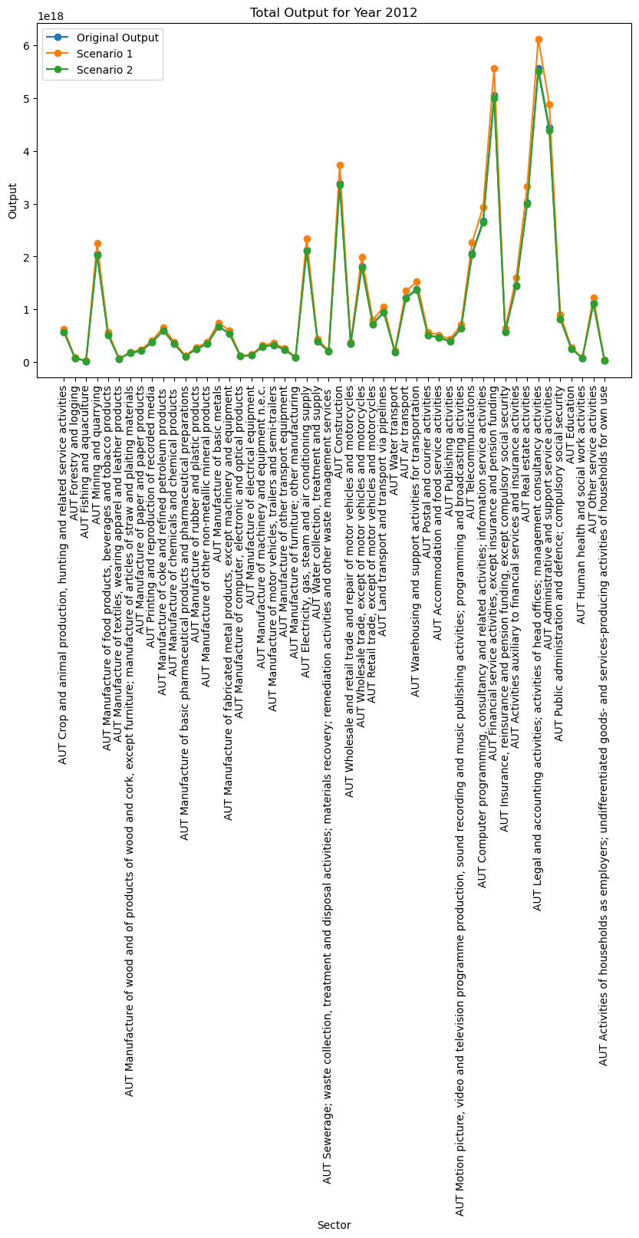

**13.Garph for 2013:**

**14.Garph for 2014:**

**Discussion**

The analysis of consumption-based CO2 emissions using the Environmentally Extended Multiregional Input-Output (MRIO) database provides a comprehensive understanding of the environmental implications of different sectors and scenarios. The study reveals the complexity of carbon accounting and highlights the need for a multifaceted approach to reducing carbon emissions.

One of the key findings of the study is the fluctuating yet overall increase in consumption-based CO2 emissions over the analyzed period. This trend suggests that while there have been concerted efforts to reduce emissions, increasing consumption levels have offset some of these gains. This finding underscores the importance of not only focusing on reducing emissions at the production level but also addressing the role of consumption patterns in contributing to CO2 emissions.

The sectoral analysis identifies manufacturing, transportation, and utilities as the major contributors to the country’s carbon emissions. These sectors present significant opportunities for implementing emission reduction strategies. However, the effectiveness of these strategies would depend on a range of factors, including technological advancements, policy interventions, and changes in consumer behavior.

The comparison of consumption-based emissions with production-based emissions reveals a significant shift in emissions responsibility. The discrepancy underscores the importance of considering global supply chains in national carbon accounting practices. It also highlights the need for international cooperation in addressing carbon emissions, as the emissions are not confined to the geographical boundaries of the country where the consumption occurs.

The future scenarios explored in the study provide valuable insights into the potential outcomes of different strategies or conditions. They illustrate the potential impact of various policies and strategies on the country’s carbon footprint. However, without specific details about what each scenario entails, it’s challenging to draw definitive conclusions or recommendations.

**Conclusion**

In conclusion, the study provides a comprehensive understanding of the consumption-based CO2 emissions in the chosen country and the potential impact of different future scenarios. The findings highlight the complexity of carbon accounting and the need for a multifaceted approach to reducing carbon emissions.

However, these findings should be interpreted with caution due to the inherent uncertainties and limitations in the data and methodology. Further research is needed to refine these estimates and develop more accurate and robust carbon accounting practices.

The study underscores the importance of scenario planning in understanding the potential outcomes of different strategies or conditions. It also highlights the need for robust systems to manage fluctuations and ensure consistent output. The insights gained from this analysis can inform policy decisions and guide future research in the field of consumption-based carbon emissions.

Overall, the study contributes to the growing body of literature on consumption-based carbon emissions and provides valuable insights for policymakers, industry leaders, and researchers. It underscores the need for a holistic approach to carbon accounting that considers both production and consumption aspects. As the world grapples with the challenges of climate change, studies like this one play a crucial role in informing strategies to reduce carbon emissions and move towards a more sustainable future.

**References**

Wiedmann, T. O., et al. (2011). "Study on the carbon footprint of global trade."

Lenzen, M., et al. (2012). "Mapping the structure of the world economy."